**Assignment -2**

Data Visualization and Pre-processing

|  |  |
| --- | --- |
| Assignment Date | 21 September 2022 |
| Student Name | K.Dinesh Kumar |
| Student Roll Number | 510119104006 |
| Maximum Marks | 2 Marks |

**Question-1:**

**Download the dataset:**

The dataset “Churn_Modelling.csv” was downloaded Successfully

**Question-2:**

**Load the Dataset:**

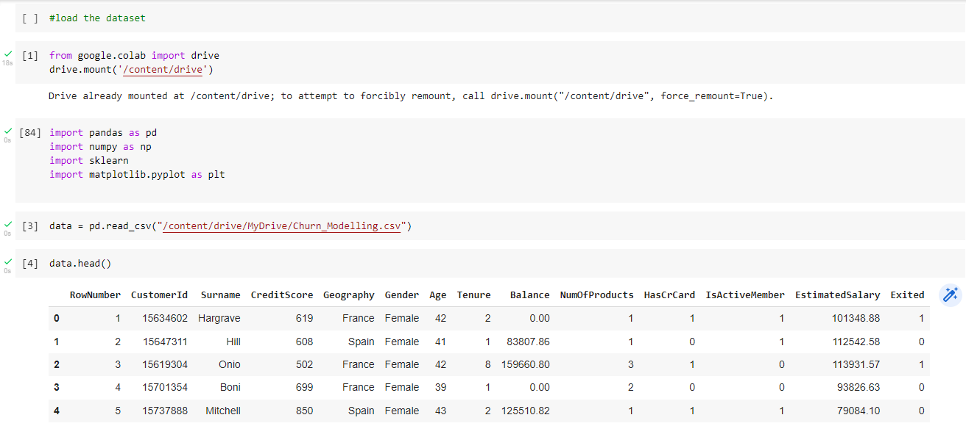

**Question-3:**

**Perform Below Visualization:**

**Univariate Analysis**

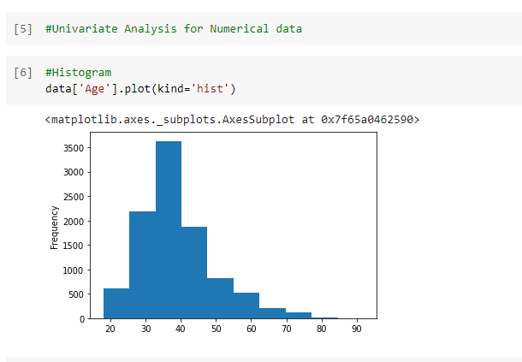

 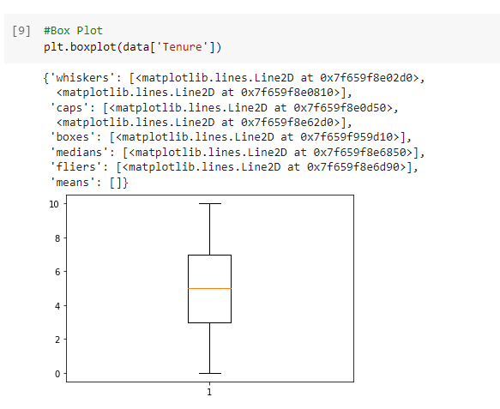

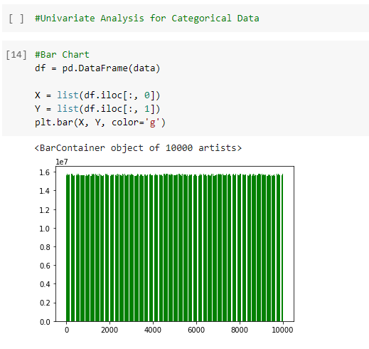

**Bivariate Analysis**

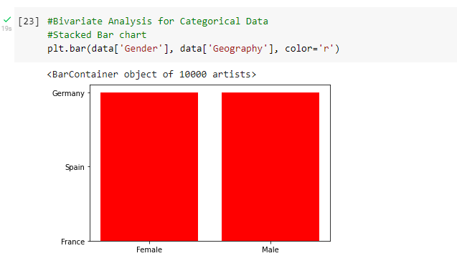

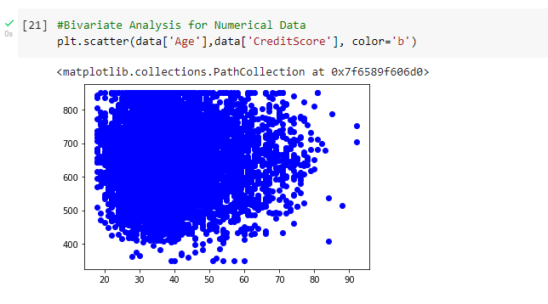

**Multivariate Analysis**

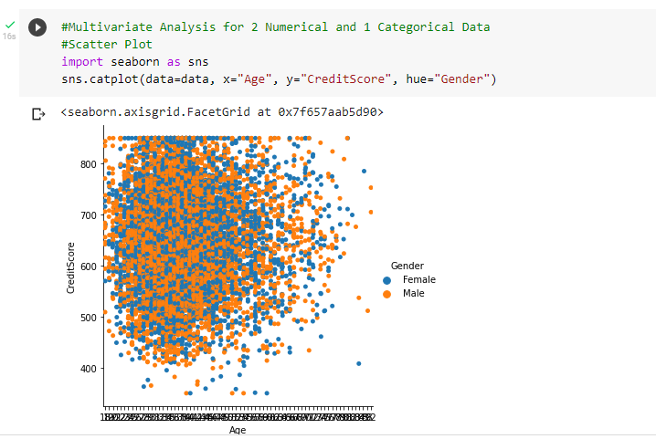

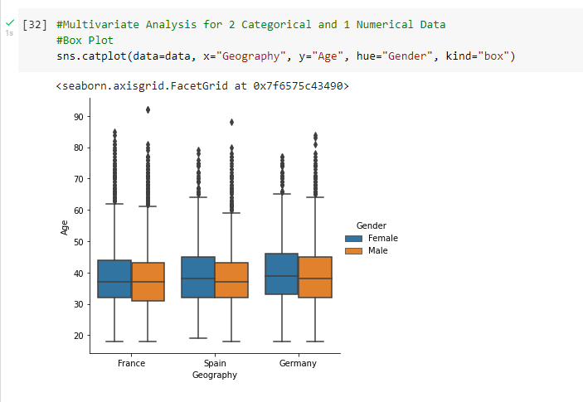

**Question-4:**

**Perform Descriptive Statistics on the dataset:**

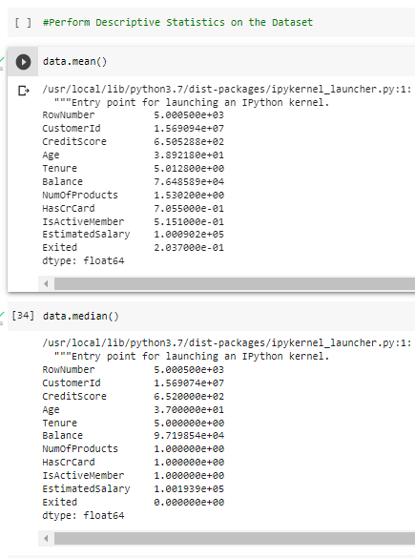

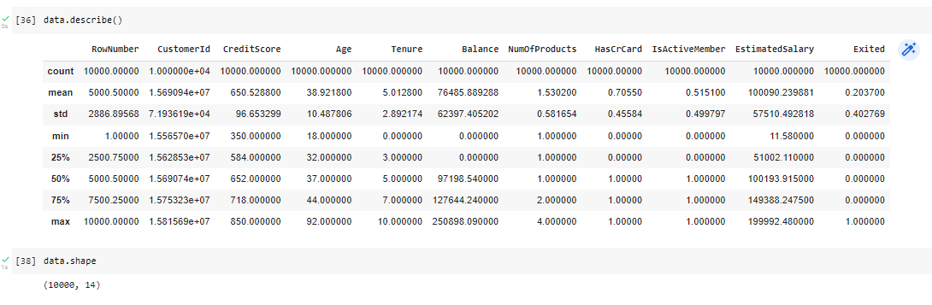



**Question-5:**

**Handle the Missing values:**

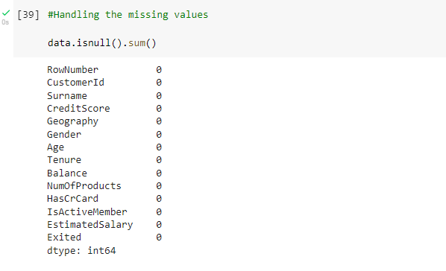

**Question-6:**

**Find the outliers and replace the outliers:**

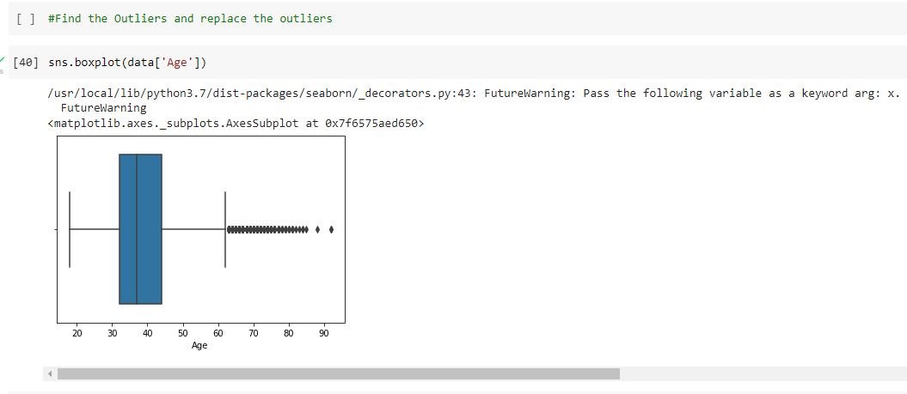

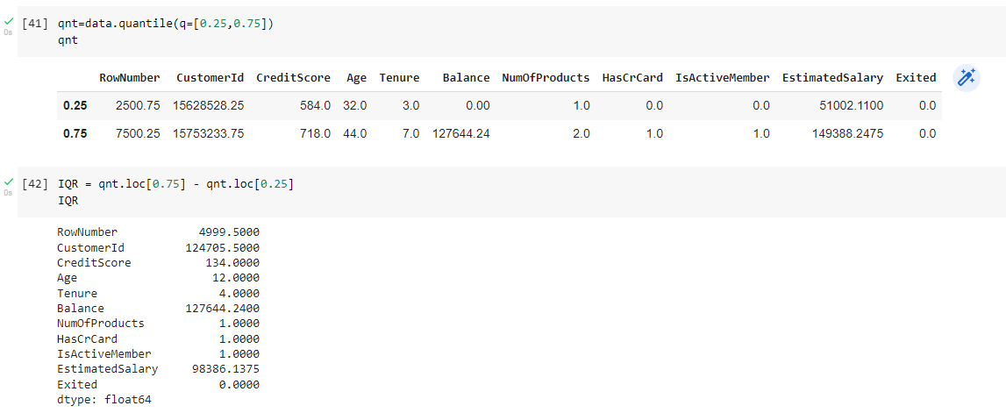

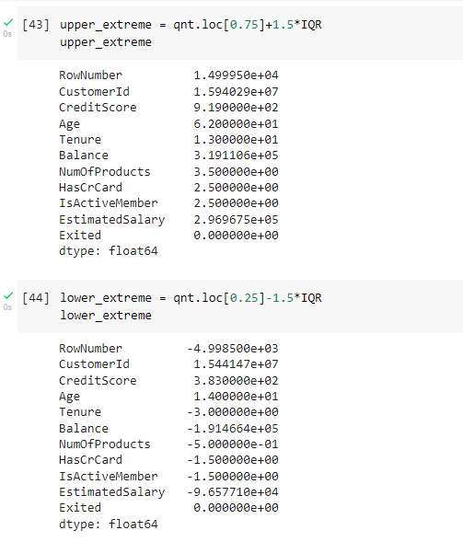

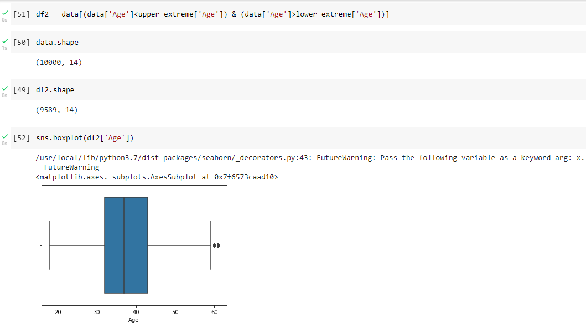

**Question-7:**

**Check for Categorical columns and perform Encoding:**

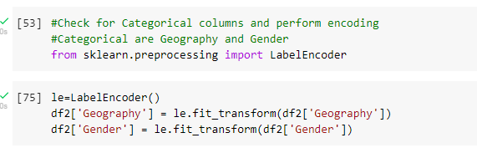

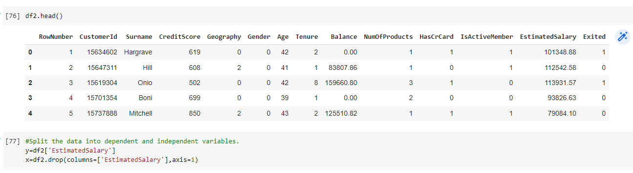

**Question-8:**

**Split the data into dependent and independent variables:**



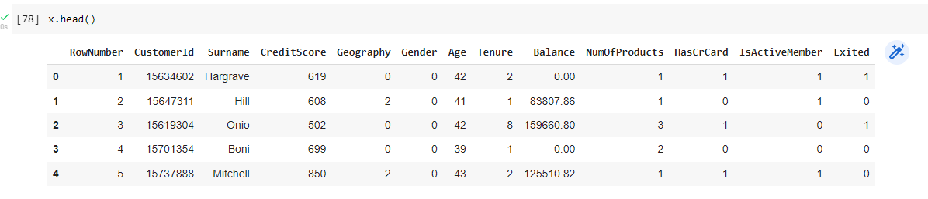

**Question-9:**

**Scale the independent variables:**

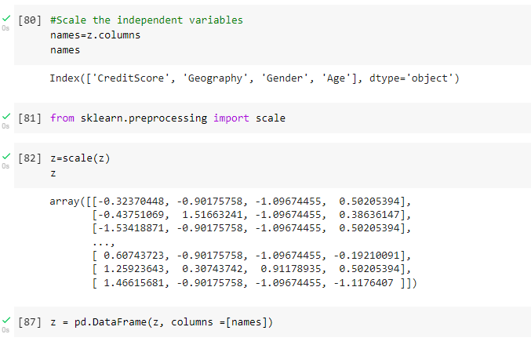

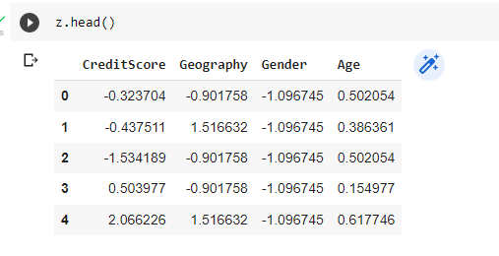

**Question-10:**

**Split the data into training and testing:**

